ABSTRACT
ABSTRACT
Airline Reservation System contains the details about flight schedules and its fare tariffs, passenger reservations and ticket records. An airline’s inventory contains all flights with their available seats. The inventory of an airline service is generally divided into three category of classes (e.g. First, Business or Economy class) and each category is having seats up to 26 bookings, along with prices and booking conditions. Inventory data is imported and maintained through a Schedule Distribution System over standardized interfaces. One of the core functions of the inventory management of airline reservations is the inventory control. Inventory control steers how many seats are available for the different booking classes, by opening and closing individual booking classes for sale. In combination with the fares and booking conditions stored in the Fare Quote System the price for each sold seat is determined.

INTRODUCTION
ABOUT ORGANIZATION

Organization Profile:
3Edge Solutions is an IT-industry sponsored initiative promoted by professionals from the IT domain with a combined experience of over 125+ years. The company specializes in corporate training in technology, industry methodologies and practices, business communication and soft skills. Over the years, 3Edge has built strong tie-ups with reputed organizations such as Scope International, Cognizant Technology Solutions, Servion Global Solutions and Oracle.
With the knowledge bank of experienced professionals in IT consulting, 3Edge Solutions have developed and continue to work on many domestic and global Software Development projects. In the past, 3Edge Solutions has developed web based application like online Trading portals, electronic Shareholders Forum and a Workflow accounting portal for an accounting firm. Some of the ongoing projects include online pharmacy and Web based clinical trials for US based client. 3Edge is also involved in developing pedagogical tools such as e-Learning, course-ware and question banks for various corporate. 3Edge Solutions has developed industry based curriculum for an Engineering University based in Washington, USA.
3Edge Solutions has been recognized as a “Knowledge Partner” to Govt. of Andhra Pradesh for enhancing employ-ability in IT and ITES sectors in the state. 3Edge is also assisting ICT Academy of Tamil Nadu (ICTACT) to train faculty in all Engineering Colleges of Tamil Nadu in industry-oriented curriculum.

EXISTING SYSTEM
The problems with the existing system is if a person want to plan for a trip he need to go to a
ticketBooking agent there he need to follow the instructions given by the agent . Because of
this person may not be totally satisfied.
The solution to this to develop single stop system where he can book tickets easily from any
Where at any time.
For every info about airlineschedules,fares and seatsavailability customer should go to
Ticket booking agent.

PROPOSED SYSTEM
In our proposed system any user can register him/her self with the site and enjoy benefits
Provided.
The various features which may be provided by our system include
- Booking a ticket easily through web.
- Viewing available seats through web.
- Viewing flight schedules through web.
- Cancelling ticket through web.

REQUIREMENT S
REQUIREMENTS
Hard ware Requirements
Processor : Intel Pentium3
RAM : 512MB
Hard disk : 2GB
Software Requirements
Front end : .Net Framework 2.0
Back end : SQL Server 2005
Tools : Microsoft Visual Studio 2005, Ms-office
Language : ASP. Net with C#.Net
Operating System : Windows 98/XP

MODULE DESCRIPTION
MODULE DESCRIPTION
Administrator module:
- Administrator maintains airline schedule fare and timings of the flight.
- Administrator can view available seats.
- Administrator can view passenger list.
- Administrator can view cancellation request.
- Administrator can cancel tickets.
- Administrator can update flight schedule and timings and fare.

Customer module:
- Customer can view airline schedules,timings, faredetails and seats availability.
- Customer can Book tickets.
- Customer can send request to admin for cancelling the ticket.

DESIGN
USECASE DIAGRAM
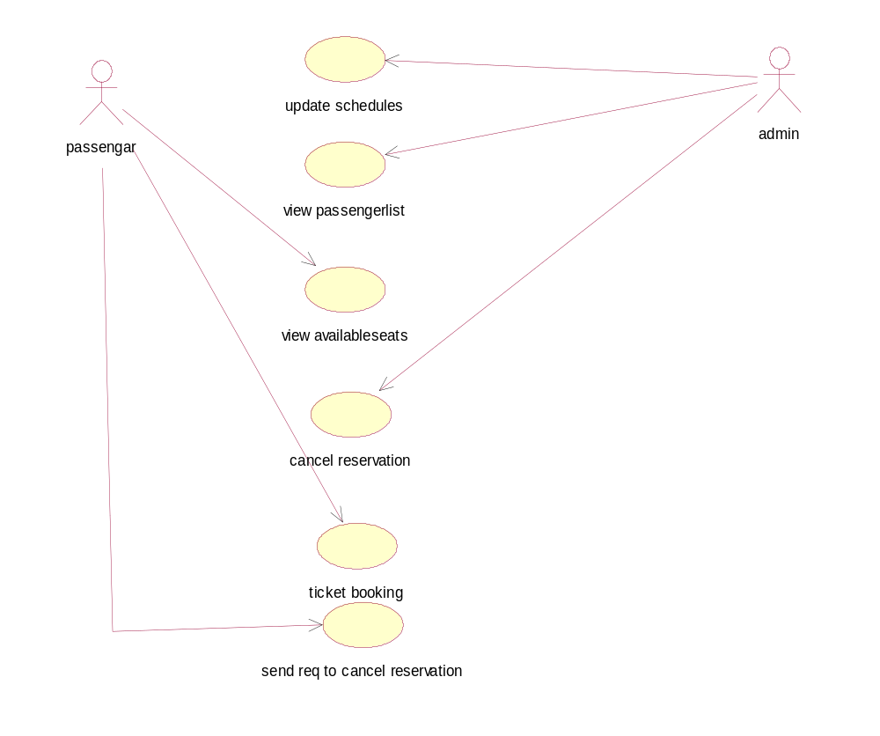
Usecase diagram for Airline system.

CLASS DIAGRAM

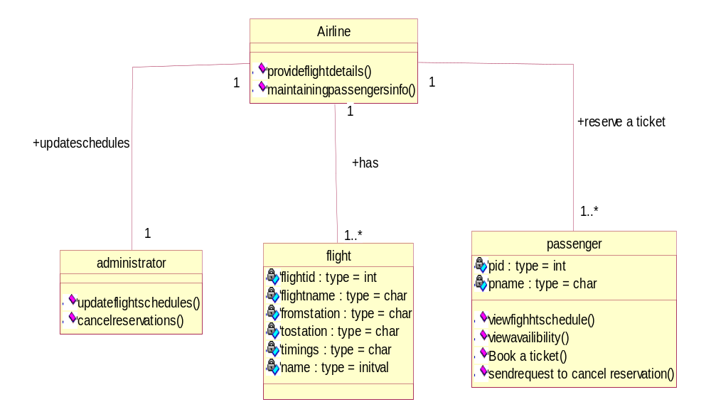
Class diagram for Air line system

SEQUENCE DIAGRAM

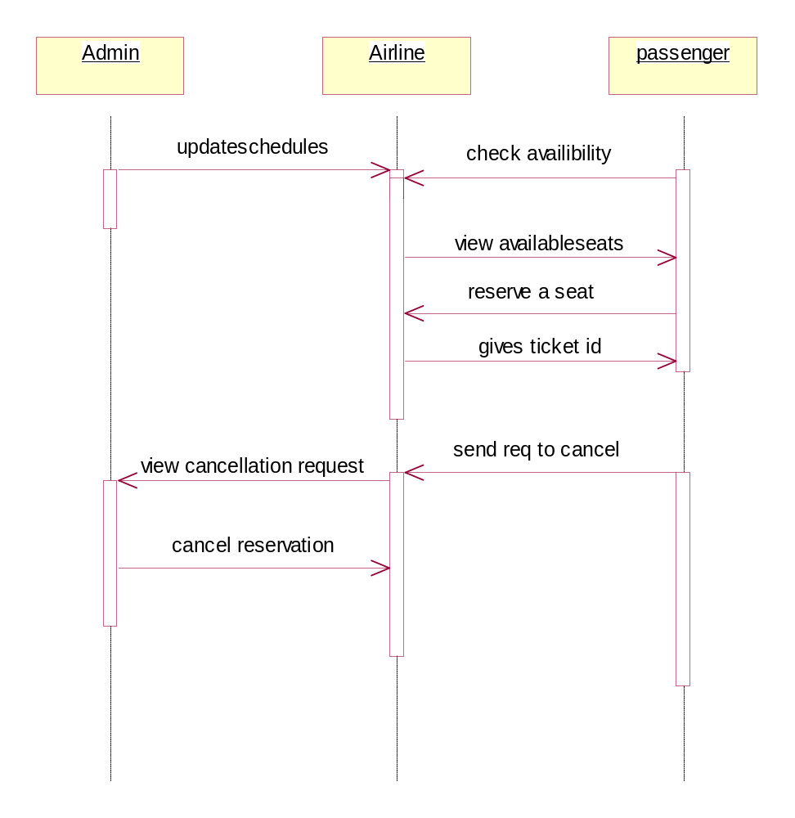
Sequence diagram for Airline system

COLLABORATION DIAGRAM

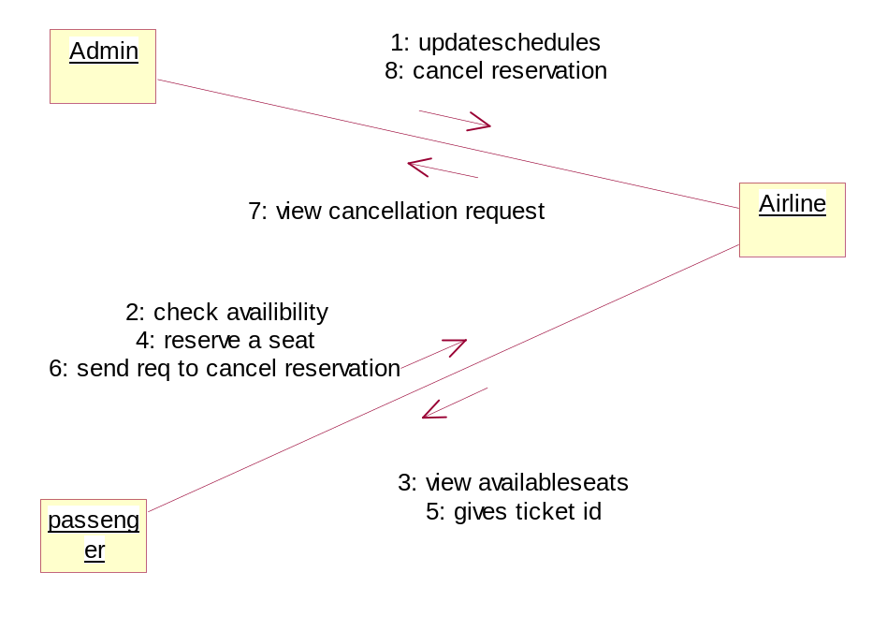
Collaboration diagram for Airline system

STATE CHART DIAGRAM

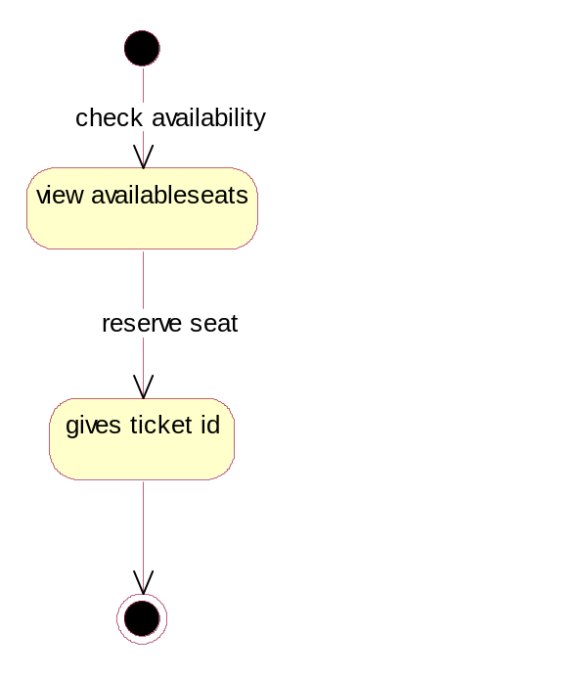

State chart diagram for Ticket booking

ERDIAGRAM
Passenger
dateandtimings no
Tostation
Fromstationn
pname
Flight id

pid
Flight name
Flight
Flightid
Flightnameeme
Fromstation
Economic
class
Bussiness
Firstclass
Tostation
Dateand
timings
reserve
ERdiagram for Air line system

DATA DICTIONARY

Registration table

Table No: | 1
Table Name | Registration
Attribute name | Data types | Constraints | Sample values
Name | varchar(50) | Not-null | Ram
Address | varchar(MAX) | Not-null | 2-34,bankcolony,wgl
Emailid | Varchar(50) | Not-null | ram@gmail.com
Username | varchar(50) | Primarykey | Ram
Password | varchar(50) | Not-null | 5624617473

Airline schedule Table
Table No | 2
Table name | Schedule
Attribute name | Data types | Constraints | Sample values
Flight id | Int | Primary key | 1006
Flight Name | varchar(50) | Not-null | Kingfisher
From station | varchar(50) | Not-null | Hyderabad
Tostation | varchar(50) | Not-null | Newyork
Firstclass | Int | Not-null | 26
Bussiness classs | Int | Not-null | 26
Economic class | Int | Not-null | 26
Date and timings | Datetime | Not-null | 12/07/2010 12:00AM

Fare and Tariffs Table
Table No | 3
Table name | Fares and tariffs
Attribute name | Data types | Constraints | Sample values
Sid | Int | Primary key | 1
Flight id | Int | Foreign key | 1006
Flight Name | varchar(50) | Not-null | Kingfisher
From station | varchar(50) | Not-null | Hyderabad
Tostation | varchar(50) | Not-null | Newyork
Firstclass | Money | Not-null | 26
Bussiness classs | Money | Not-null | 26
Economic class | Money | Not-null | 26
Date and timings | Datetime | Not-null | 12/07/2010 12:00AM

Cancellation request table
Table No | 4
Table name | Cancellation req
Attribute name | Data types | Constraints | Sample values
Pid | Int | Primary key | 1
Pname | varchar(50) | Not-null | ram

Passengerlist Table

Table No | 5
Table name | Plist
Attribute name | Data types | Constraints | Sample values
Pid | Int | Primary key | 1
Pname | varchar(50) | Not-null | Ram
Flight id | Int | Foreign key | 1006
Flight Name | varchar(50) | Not-null | Kingfisher
From station | varchar(50) | Not-null | Hyderabad
Tostation | varchar(50) | Not-null | Newyork
Date and timings | Datetime | Not-null | 12/07/2010 12:00AM

CODE

Masterpage .aspx.cs

using System;
using System.Data;
using System.Configuration;
using System.Collections;
using System.Web;
using System.Web.Security;
using System.Web.UI;
using System.Web.UI.WebControls;
using System.Web.UI.WebControls.WebParts;
using System.Web.UI.HtmlControls;

public partial class home : System.Web.UI.MasterPage
{
protected void Page_Load(object sender, EventArgs e)
{
if (Session["Type"] != null)
{
if (Session["Type"].ToString() == "admin")
{
Panel1.Visible = true;
Panel2.Visible = false;
Panel3.Visible = false;
}
else
{
Panel1.Visible = false;
Panel2.Visible = true;
Panel3.Visible = false;
}
}
else
{
Panel1.Visible = false;
Panel2.Visible = false;
Panel3.Visible = true;
}
}
protected void Menu2_MenuItemClick(object sender, MenuEventArgs e)
{

}
protected void Menu2_MenuItemClick1(object sender, MenuEventArgs e)
{

}
protected void LinkButton1_Click(object sender, EventArgs e)
{
Session.RemoveAll();
Response.Redirect("login.aspx");
}
}

Login.aspx.cs
using System;
using System.Data;
using System.Configuration;
using System.Collections;
using System.Web;
using System.Web.Security;
using System.Web.UI;
using System.Web.UI.WebControls;
using System.Web.UI.WebControls.WebParts;
using System.Web.UI.HtmlControls;
using System.Data.SqlClient;
public partial class login : System.Web.UI.Page
{
protected void Page_Load(object sender, EventArgs e)
{
}
String constring=StringConfigurationManager.ConnectionStrings["conn"].
ConnectionString.ToString();
protected void Button1_Click(object sender, EventArgs e)
{
SqlConnection con=new SqlConnection(constring);
SqlCommand cmd=new SqlCommand() ;
cmd.CommandType=CommandType.Text;
cmd.Connection=con;
con.Open();
cmd.CommandText="select username,Type from Reg where username='"+TextBox1.Text+"'
and password='"+TextBox2.Text+"'";
SqlDataAdapter da = new SqlDataAdapter();
da.SelectCommand=cmd;
DataSet ds=new DataSet();
da.Fill(ds,"emp");
if(ds.Tables["emp"].Rows.Count>0)
{
Session["Type"]=ds.Tables["emp"].Rows[0]["Type"].ToString();
Response.Redirect("home.aspx");
}
else
{
Label.Visible=true;
Label.Text="error";
}
con.Close();
}
}

Registration.aspx.cs
using System;
using System.Data;
using System.Configuration;
using System.Collections;
using System.Web;
using System.Web.Security;
using System.Web.UI;
using System.Web.UI.WebControls;
using System.Web.UI.WebControls.WebParts;
using System.Web.UI.HtmlControls;
using System.Data.SqlClient;
public partial class registration : System.Web.UI.Page
{
protected void Page_Load(object sender, EventArgs e)
{
}
protected void TextBox2_TextChanged(object sender, EventArgs e)
{
}
String constring=ConfigurationManager.ConnectionStrings["conn"].ConnectionString.
ToString()
protected void Button1_Click(object sender, EventArgs e)
{
SqlConnection con = new SqlConnection(constring);
SqlCommand cmd = new SqlCommand();
cmd.CommandType = CommandType.Text;
cmd.Connection = con;
con.Open();
cmd.CommandText = "insert into Reg(Name,Address,Emailid,username,password,Type)
values('" + TextBox1.Text + "','" + TextBox2.Text + "','" + TextBox3.Text + "','" +
TextBox4.Text + "','" + TextBox5.Text + "','"+DropDownList1.Text+"')";
int i = cmd.ExecuteNonQuery();
if (i>0)
{
Label.Visible = true;
Label.Text = "sucess";
}
else
{
Label.Visible = true;
Label.Text = "error";
}
con.Close();
}
}

Ticketbooking.aspx.cs
using System;
using System.Data;
using System.Configuration;
using System.Collections;
using System.Web;
using System.Web.Security;
using System.Web.UI;
using System.Web.UI.WebControls;
using System.Web.UI.WebControls.WebParts;
using System.Web.UI.HtmlControls;
using System.Data.SqlClient;
public partial class registration : System.Web.UI.Page
{
protected void Page_Load(object sender, EventArgs e)
{

}
protected void TextBox2_TextChanged(object sender, EventArgs e)
{

}
String constring =ConfigurationManager.ConnectionStrings["conn"].ConnectionString
.ToString();

protected void Button1_Click(object sender, EventArgs e)
{
SqlConnection con = new SqlConnection(constring);
SqlCommand cmd = new SqlCommand();
cmd.CommandType = CommandType.Text;
cmd.Connection = con;
con.Open();
cmd.CommandText = "insert into Reg(Name,Address,Emailid,username,password,Type)
values('" + TextBox1.Text + "','" + TextBox2.Text + "','" + TextBox3.Text + "','" +
TextBox4.Text + "','" + TextBox5.Text + "','"+DropDownList1.Text+"')";
int i = cmd.ExecuteNonQuery();
if (i>0)
{
Label.Visible = true;
Label.Text = "sucess";
}
else
{
Label.Visible = true;
Label.Text = "error";
}
con.Close();
}
}

Sendreq.aspx.cs
using System;
using System.Data;
using System.Configuration;
using System.Collections;
using System.Web;
using System.Web.Security;
using System.Web.UI;
using System.Web.UI.WebControls;
using System.Web.UI.WebControls.WebParts;
using System.Web.UI.HtmlControls;
using System.Data.SqlClient;

public partial class canreq : System.Web.UI.Page
{
protected void Page_Load(object sender, EventArgs e)
{
}
String constring=ConfigurationManager.ConnectionStrings["conn"].ConnectionString.
ToString();
protected void Button1_Click(object sender, EventArgs e)
{
SqlConnection con = new SqlConnection(constring);
SqlCommand cmd = new SqlCommand();
cmd.CommandType = CommandType.Text;
cmd.Connection = con;
con.Open();
cmd.CommandText = "insert into canreq(pid,pname) values('"+TextBox1.Text+"','
"+TextBox2.Text+"')";
int i = cmd.ExecuteNonQuery();
if (i>0)
{
Label.Visible = true;
Label.Text = "sucess";
}
else
{
Label.Visible = true;
Label.Text = "error";
}
con.Close();
}
}

TESTING
TEST CASES
1.Test case : LOGIN
Input : ID,Password.
Process :Click on login Link .If username and password is of admin type display admin
Services .Else if username and password is of user type display user services.
If username and password is invalid display error message.
Output : Display services depending on type

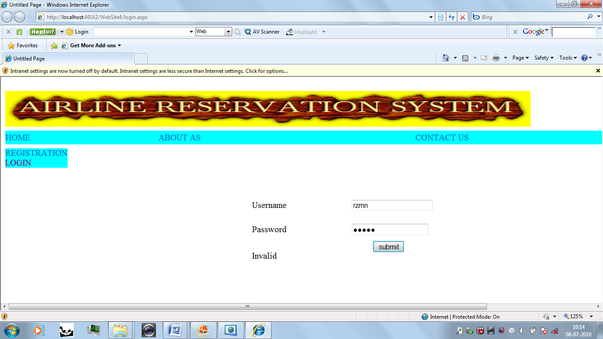

2.Test case : Registration
Input : Name, Address,emailid,username,password.
Process :Click on Registation Link. Enter inputs to the form and submit it.
Output: Displays success message

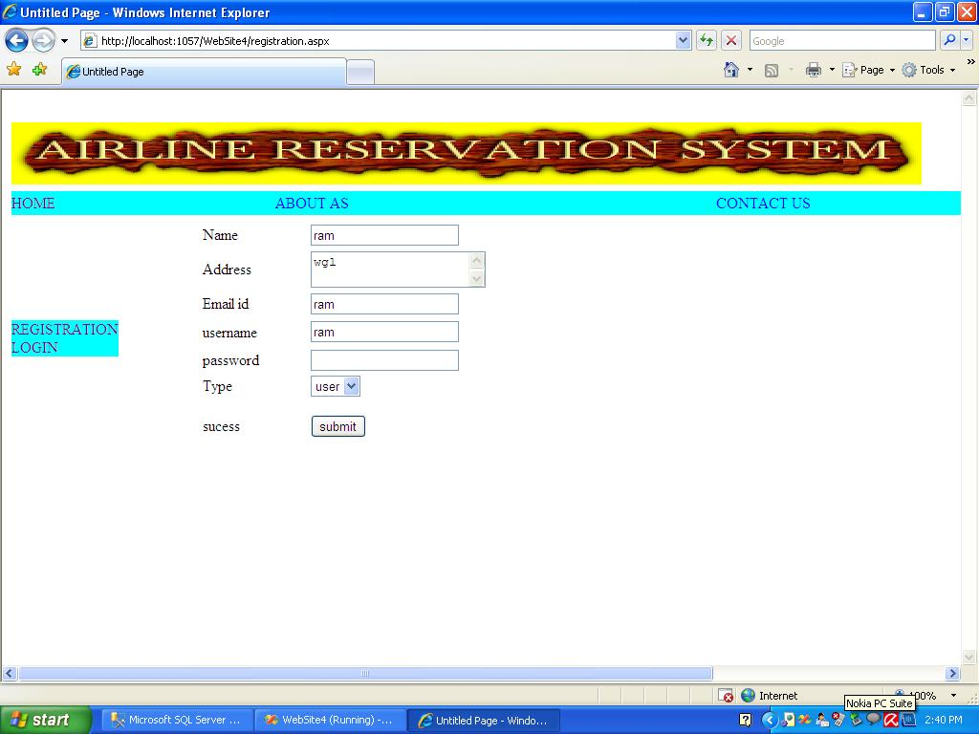

3.Test case : Ticket Booking
Input : Flightid,Flight name,fromstation,Tostation,Date and Timings and category.
Process :Click on Ticketbooking Link. Enter inputs to the form and submit it.
Output: Displays success message and gives passenger id.

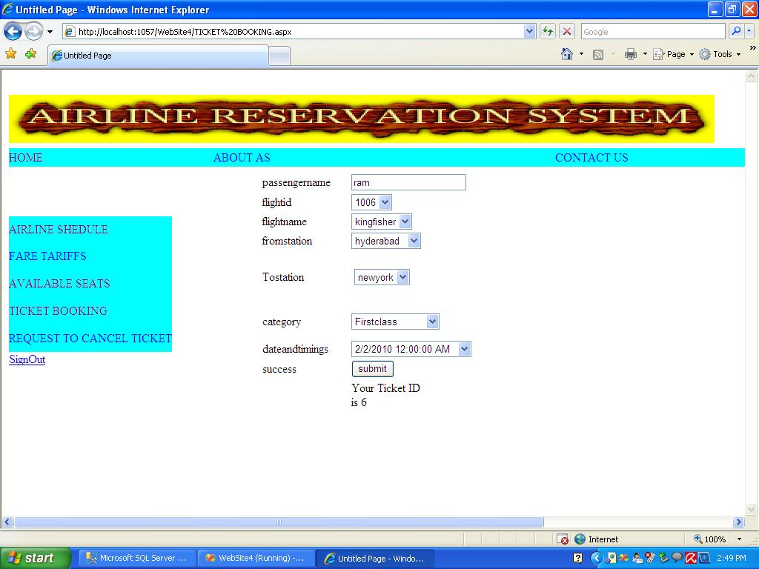

4.Test case : Send req to cancel ticket
Input : pid,pname.
Process :Click on sendreq to cancel ticket Link. Enter inputs to the form and submit it.
Output: Displays success message .

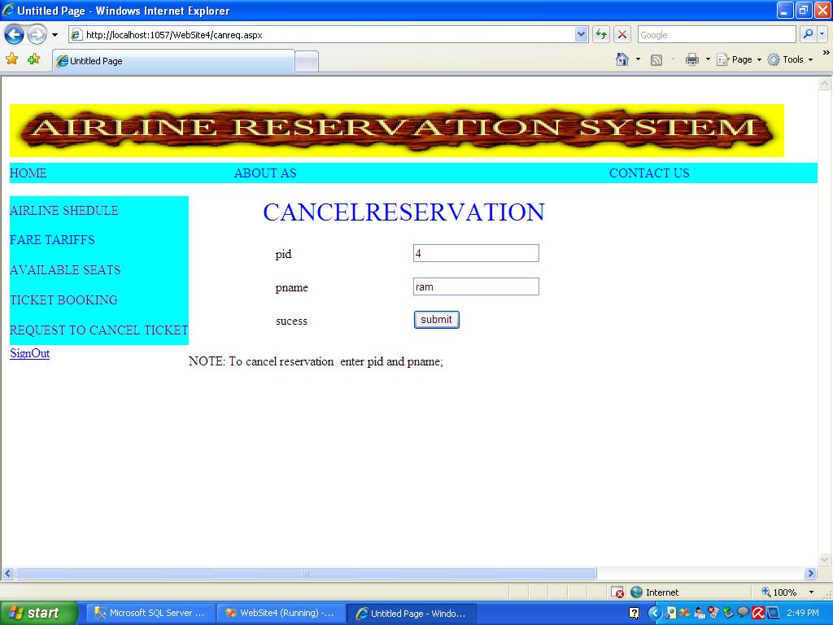

OUTPUT SCREENS
HOME PAGE

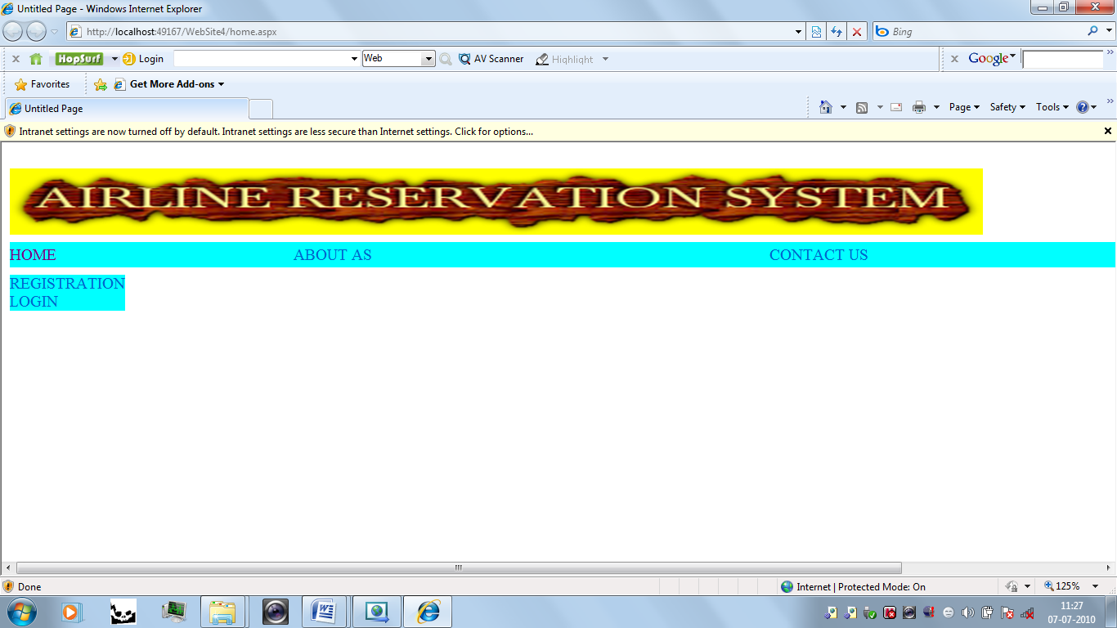

REGISTRATION PAGE

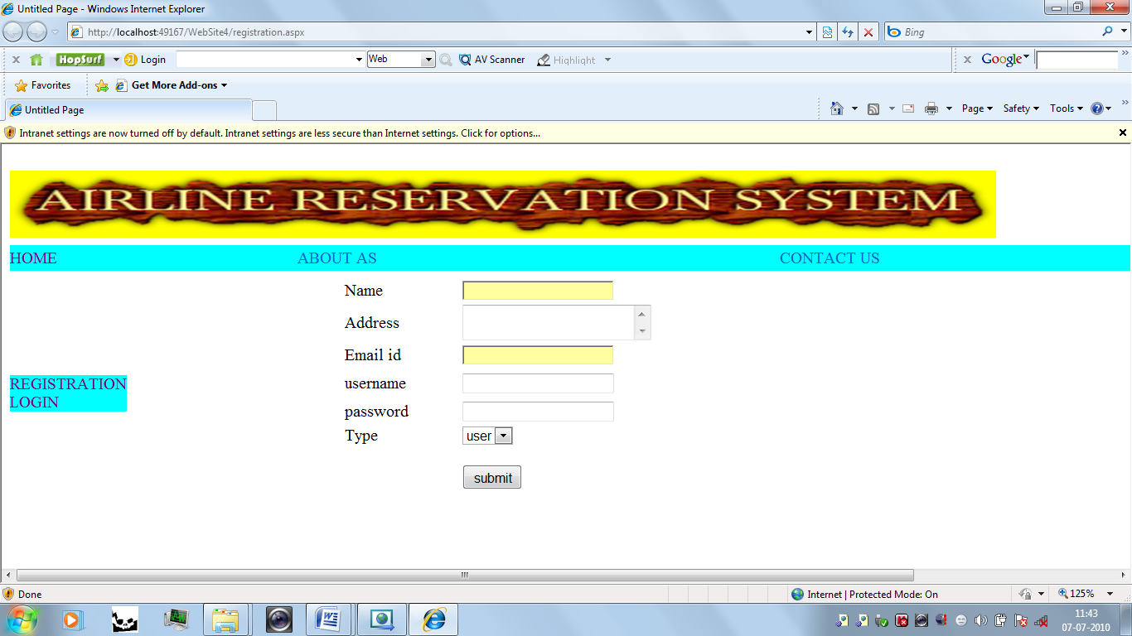

LOGIN PAGE

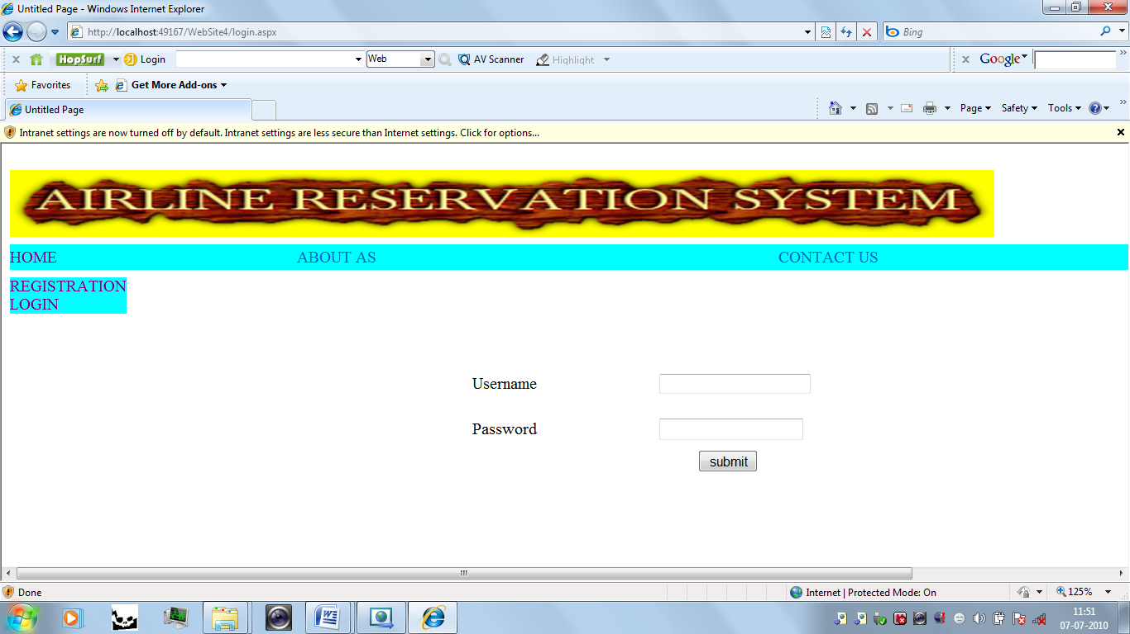

TICKETBOOKING PAGE

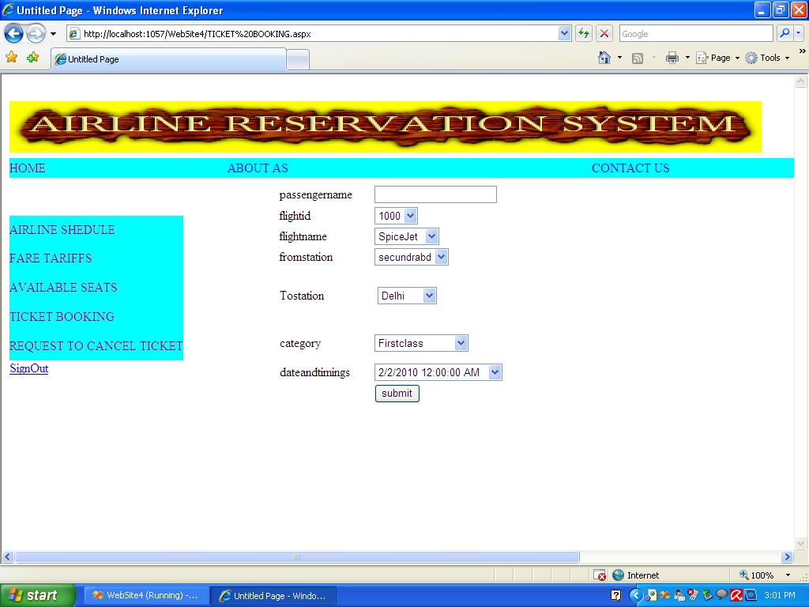

Schedule updating page

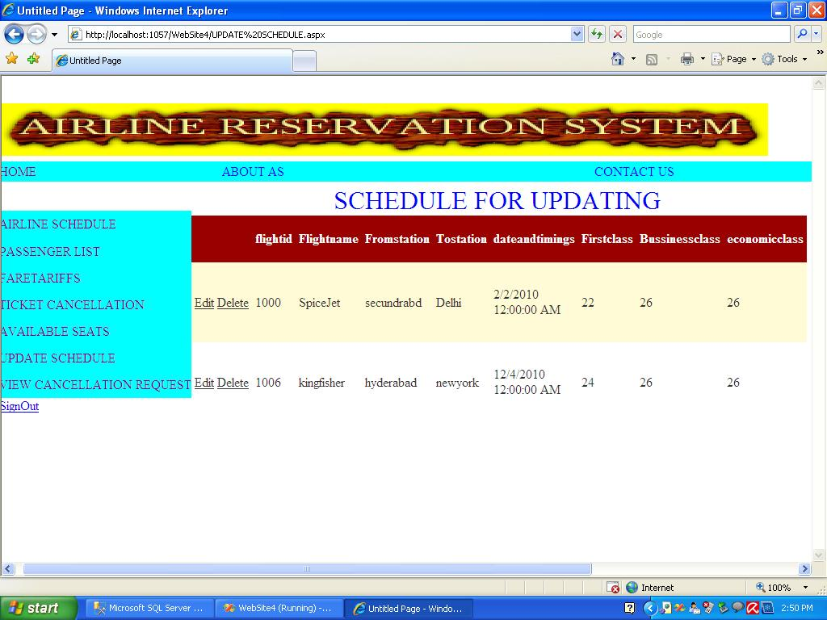

REQUEST TO CANCEL TICKET PAGE

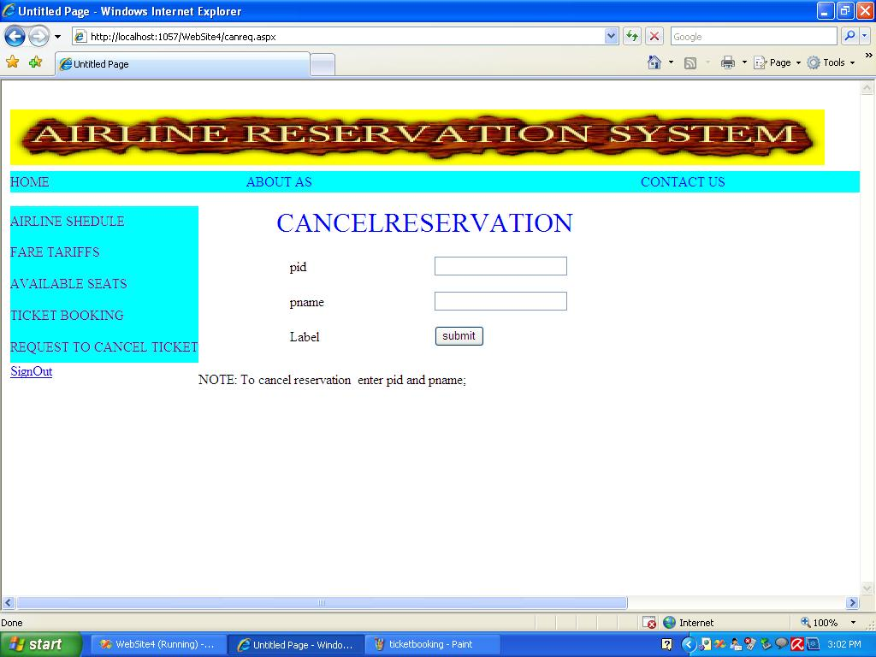

VIEW AVAILABLE SEATS

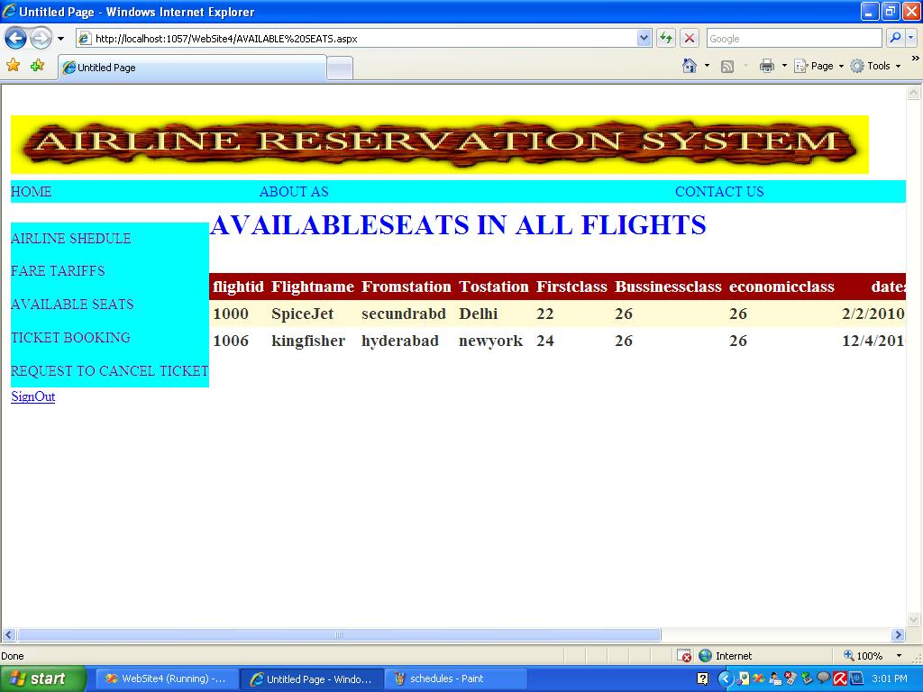

CONCLUSION AND FUTURE SCOPE

CONCLUSION
Getting accurate information about airlines and their schedules is an important part of preparing for a trip . To help you with this task we have provided information about the of flights available between various points and we have also included campanies that provide flights.
FUTURE SCOPE
Our future scope will be to arrange even hotels facility at the starting and destination points of journey .And it would also serve people in better way by doing so.

BIBLIOGRAPHY
BIBLIOGRAPHY
REFERENCES
1. SOFTWARE ENGINEERING - By Roger .S. Pressman
2. SQL FOR PROFESSIONALS - By Jain
3. ASP.Net with C# - By Wrox Publication
4. MSDN 2002 -By Microsoft

